# LetsUpgrade Cloud Computing -AWS Essentials Batch 1

**Assignment Day 4 – Project 3**

**Step1: Create two linux instances,Use the first free linux AMI**

**LINUX1 IPv4 Public IP:** 13.59.226.120

**LINUX2 IPv4 Public IP:** 18.217.46.141

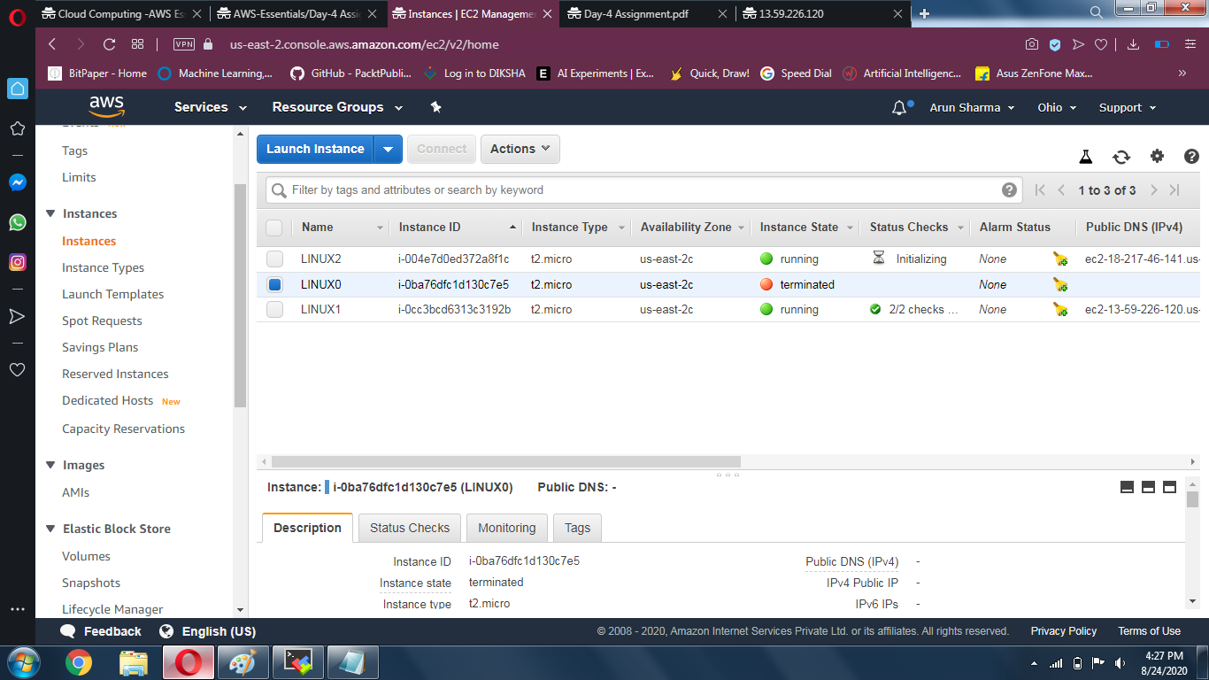

**Step2: Launch both instances using Mobaxterm and Host html login webpage on both** **servers**

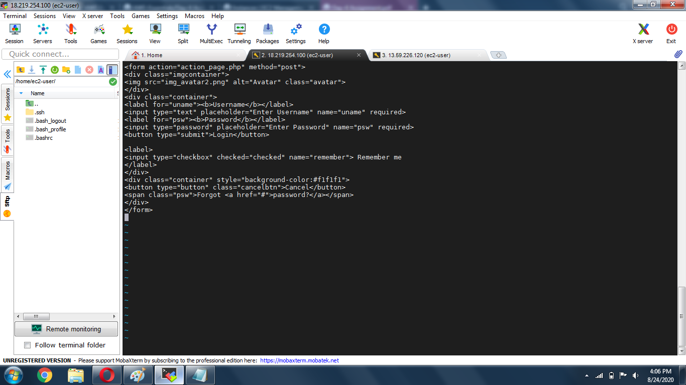

**Step 3: Check if the application is deployed on both servers by copy pasting the public ip of the servers into the browser.**

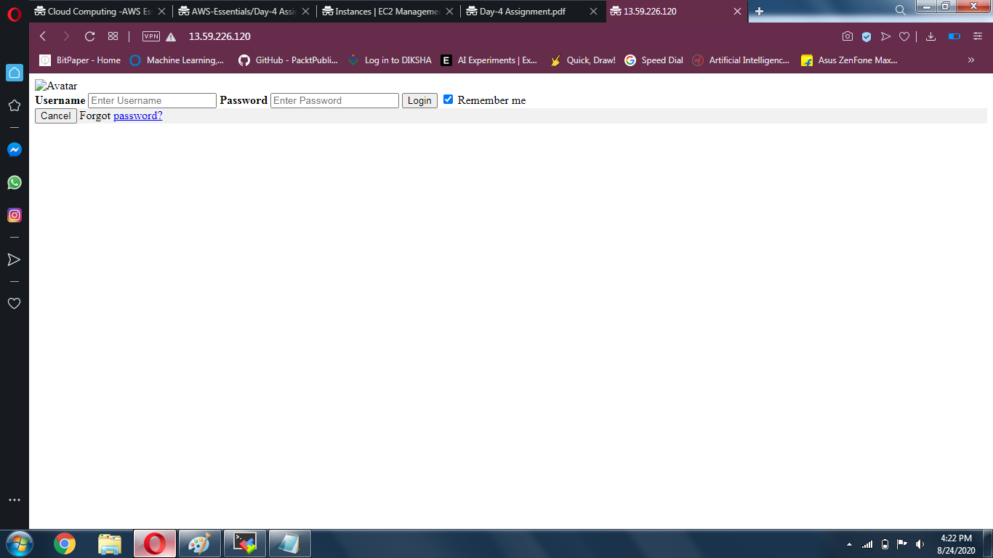

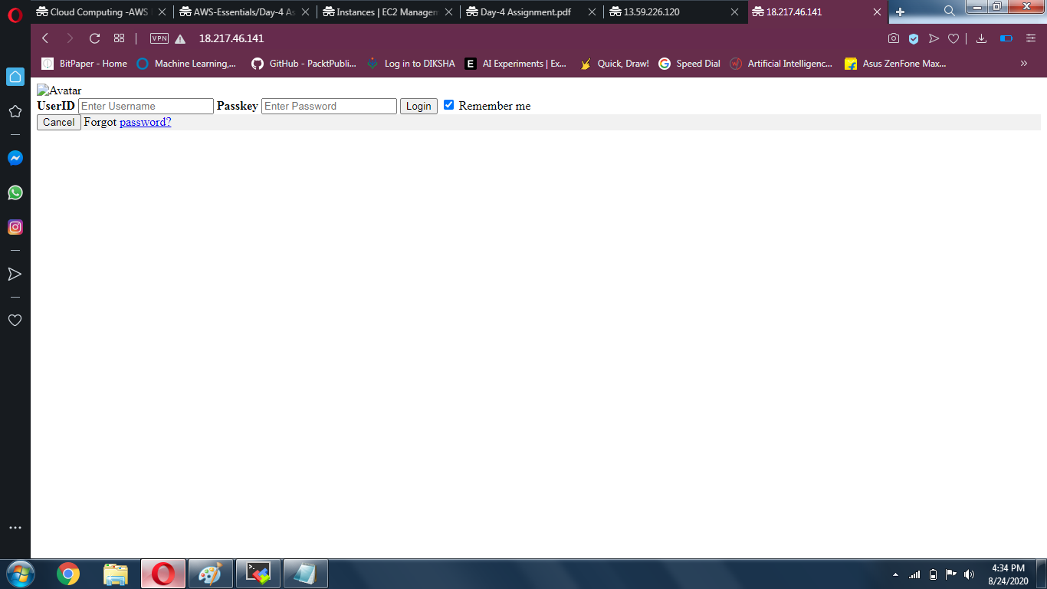

**Step 4: Create a application Load balancer with the above two instances as targets and Check the functioning of ELB**

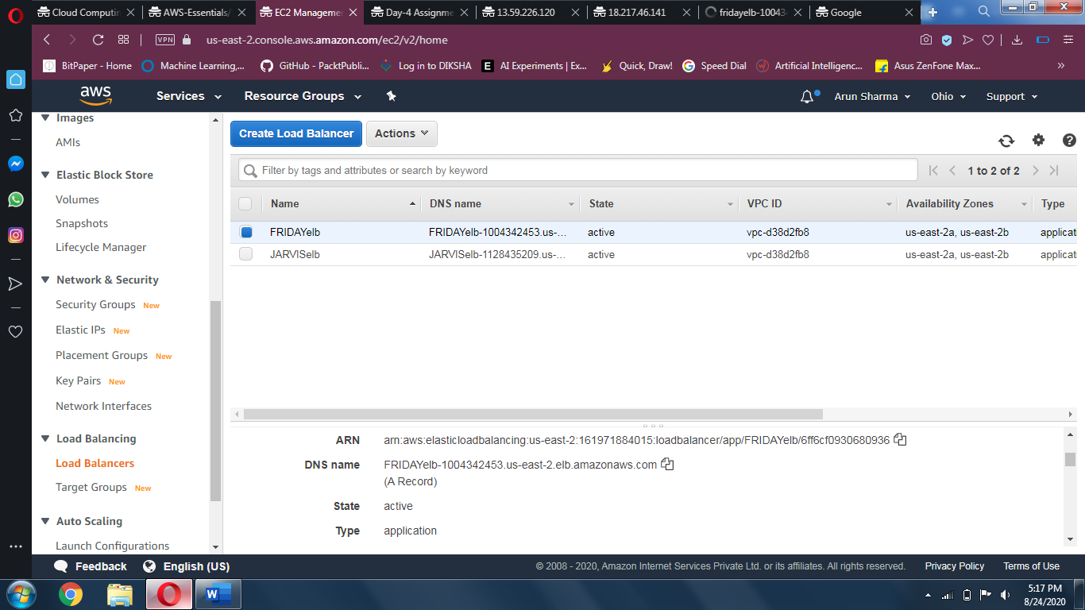

**Right now its shows an Error:503**

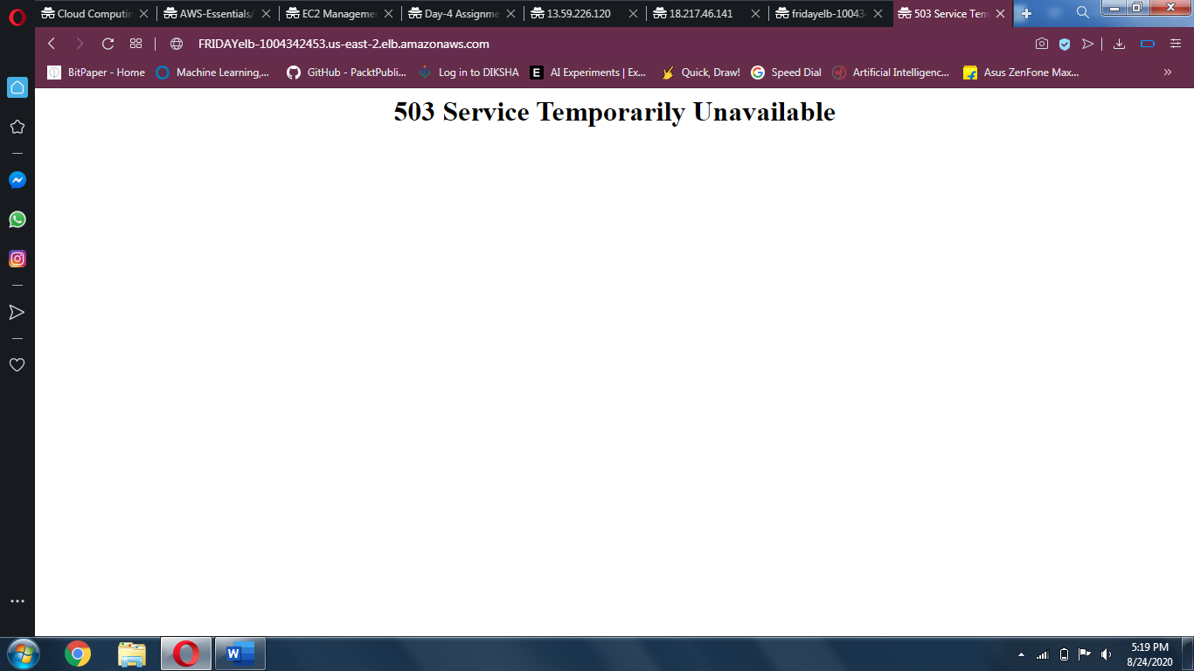

**Submitted To:** Vinolin Jermiah (AWS Instructor/LetsUpgrade)

**Submitted By:** Arun Sharma  
[curiousarun08@gmail.com](mailto:curiousarun08@gmail.com)